- Copyright for test papers and marking guides remains with West Australian Test Papers.
- The papers may only be reproduced within the purchasing school according to the advertised conditions of sale.
- Test papers must be withdrawn after use and stored securely in the school until Wednesday 5th December 2012.

PHYSICS

YEAR 11

STAGE 2B

2012



Name: _______________________________________________________

Teacher: ___________________________________________________

TIME ALLOWED FOR THIS PAPER

Reading time before commencing work: Ten minutes

Working time for the paper: Three hours

MATERIALS REQUIRED/RECOMMENDED FOR THIS PAPER

To be provided by the supervisor:
- This Question/Answer Booklet; Formula and Constants sheet

To be provided by the candidate:
- Standard items: pens, pencils, eraser or correction fluid, ruler, highlighter.

- Special items: Calculators satisfying the conditions set by the Curriculum Council for this subject.

IMPORTANT NOTE TO CANDIDATES
No other items may be taken into the examination room. It is your responsibility to ensure that you do not have any unauthorised notes or other items of a non-personal nature in the examination room. If you have any unauthorised material with you, hand it to the supervisor before reading any further.

All calculations are to be set out in detail. Marks may be awarded for correct equations and clear setting out, even if you cannot complete the calculation. Express numerical answers to two (2) or three (3) significant figures and include units where appropriate. Express estimates to one (1) or two (2) significant figures, and state any assumptions clearly.

STRUCTURE OF THE PAPER

Section | No. of  Questions | No. of questions  to be attempted | No. of marks  out of 200 | Proportion of  exam total
A: Short Answers | 15 | ALL | 80 | 40%
B: Problem Solving | 8 | ALL | 100 | 50%
C: Comprehension and  Interpretation | 2 | ALL | 20 | 10%

Note: Above refers to 3 hour paper.

INSTRUCTIONS TO CANDIDATES

Write your answers in the spaces provided beneath each question. The value of each question (out of 200) is shown following each question.

The enclosed Physics: Formulae and Constants Sheet may be removed from the booklet and used as required.

Calculators satisfying conditions set by the School Curriculum and Standards Authority may be used to evaluate numerical answers. The calculator cannot be a “graphics” calculator.

Answers to questions involving calculations should be evaluated and given in decimal form. Final answers should be given to two or three significant figures and include appropriate units where appropriate. Despite an incorrect final result, credit may be obtained for method and working providing these are clearly and legibly set out.

Questions containing specific instructions to show working should be answered with a complete, logical, clear sequence of reasoning showing how the final answer was arrived at; correct answers which do not show working will not be awarded full marks.

Questions containing the instruction "ESTIMATE" may give insufficient numerical data for their solution. Students should provide appropriate figures to enable an approximate solution to be obtained.

Section A: Short Answers

Marks allocated: 80 marks out of a total of 200 (40%)

Attempt ALL questions in this section. Not all questions attract the same marks.

Answers are to be written in the space below or next to each question.

Question 1
a) A warm bottle of drink at room temperature is placed in a refrigerator that has its temperature control set to 4 ºC. Describe the physics principles involved in the refrigerator design and the process whereby the drink becomes cooler by being placed in the refrigerator for a while. (3 marks)

b) Why doesn’t the drink freeze even if it is left under these conditions for a long time? (1 mark)

Question 2
In Western Australia electricity providers charge domestic customers 19.8 cents per kilowatt hour for “power”.
- Explain why a kilowatt hour is not a measure of “power” but a unit of energy. (2 marks)

b) If a student uses a 15 W compact fluorescent lamp to study at night for 40 weeks ESTIMATE the cost of electricity to run the lamp.
(list any estimates you use in your calculation) (3 marks)

Question 3
a) When electric current flows through a tungsten wire filament as in an incandescent globe the wire filament becomes white hot. How does the resistance in the filament differ from the resistance in regular wires (which do not heat up significantly)? (2 marks)

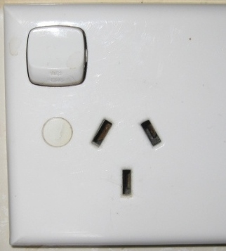
b) If a switch is placed on the neutral wire rather than the active wire in a household electrical circuit the switch is still able to turn devices on and off. However, a switch is placed on the neutral wire is potentially hazardous. Explain why. (2 marks)

Question 4
In terms of electrical theory, explain how a “dimmer” switch that is connected to a household
circuit can be used to control the brightness of lights in the house. Include a sketch of the mechanism. (3 marks)

Question 5
Double brick wall construction in houses, double glazing in windows, doonas (bed spreads)
and carpet on floors all contribute to keeping people warm in winter.
Explain in terms of heat transfer how each device helps to keep people warm.

a) Double brick wall construction (1 mark)

b) Double glazing (1 mark)

c) Carpet (1 mark)

Question 6
The diagram below represents a network of resistors.
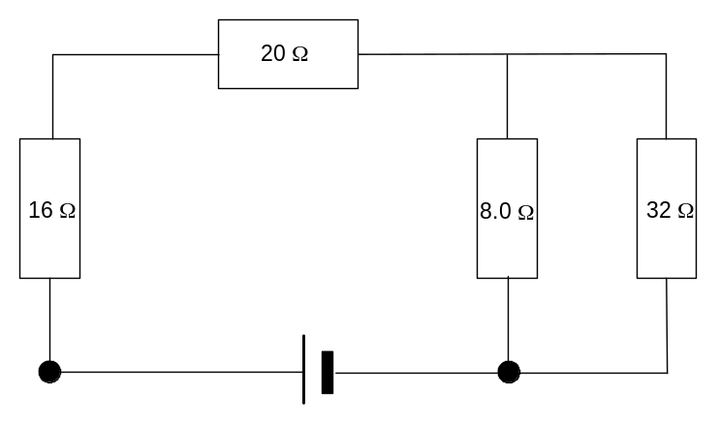

a) What is the total resistance of this network? (3 marks)

b) Which resistor(s) will carry the largest current? Explain your answer. (2 marks)

Question 7
Solar hot water heaters are installed on many houses in Western Australia.

a) Suggest a reason why Western Australia is a suitable place to install solar hot water heaters? (2 marks)

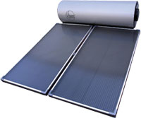

b) The intensity of the sun is approximately 850 W m⁻² and a typical heater would have an area of about 2.00 m². Calculate the temperature increase in 45 min if the mass of water in the pipes in the panel is 17.0 kg. (3 marks)

c) For the above calculation to be realistically accurate, a major assumption about the water in the heater has been made. Suggest what that assumption may be. (2 marks)

Question 8
- Ammeters have almost zero resistance. Briefly explain what would happen if an ammeter had a high resistance and why that would make it unsuitable as a measuring device in circuits.
(2 marks)

b) Voltmeters have a very high resistance. Explain why this is the case and why a voltmeter
would be unsuitable if it had a low resistance. (2 marks)

Question 9
When wet clothes are taken from a washing machine and hung on a washing line, they dry more quickly than they would if left crumpled in a clothes basket.
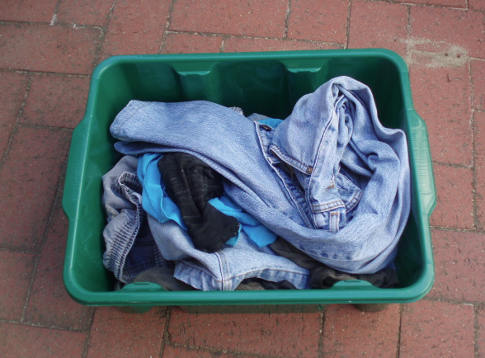
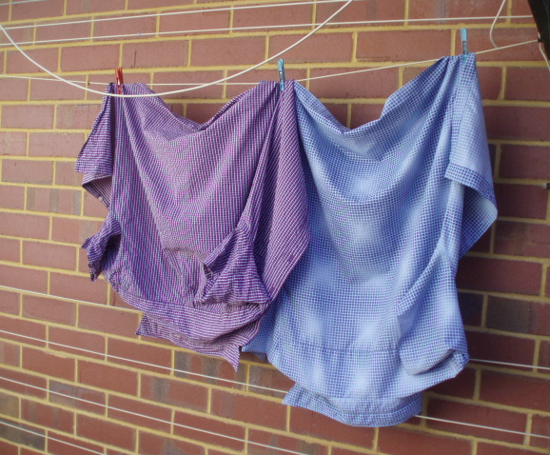

- Explain why clothes dry more quickly on the washing line than in the clothes basket (2 marks)

- Explain how the effectiveness of the drying process would change in humid conditions. (2 marks)

- State one factor that could change to increase the rate of drying of the clothes. (1 mark)

Question 10
Explain the process of heat transfer by conduction with reference to kinetic molecular theory. (3 marks)

Question 11
- Draw a circuit diagram that includes a power supply, three lamps, and three switches, where
each switch controls one lamp. (4 marks)

b) If one of the lamps was “blown” would the other two lamps still operate when switched on? Explain in terms of parallel and series circuit theory. (2 marks)

Question 12
A cyclist wants to take a bottle of cold water on a long ride .To prepare the water she places
50 mL of tap water at 22.0 ºC in an insulated bottle and adds ice at 0 ºC. When all the ice has
melted the temperature of the water is 5.0 ºC.

a) What mass of ice at 0 º C should she add? (4 marks)

b) Describe one action the cyclist could take to ensure the water stayed colder for a longer time. (2 marks)

Question 13
A coffee machine that makes cappuccinos heats 5.00 g of water from 25.0 ºC to 100.0 ºC and
then converts the water to steam which is used to heat milk in a cup by squirting the steam
into a cup containing the milk. Calculate the electrical energy required to:

a) change the temperature of 5.00 g of water in an insulated kettle from 25.0 ⁰C to 100.0 ⁰C. (3 marks)

b) convert the heated water into steam. (2 marks)

c) If the coffee machine is connected to the mains (240 V) how long will it take the machine to produce the total energy to heat the water and convert it to steam if the heating coil in the machine has a resistance of 5.0 ohms? (4 marks)

Question 14
The electrical system in a car utilises a 12 V battery that delivers current to its various electrical components. Not all electrical components, in the car, use the same current.

a) Explain how the car’s radio and headlights, which both require different currents, can function successfully while connected to the same 12 V battery. (3 marks)

- The car’s headlight is rated as 12.0 volts and 65.0 W. What current would the headlight draw
if it was operating at its rated potential? (2 marks)

- How much energy is consumed by the headlight if it is switched on for 45.0 minutes? (2 marks)

- What is the resistance of the headlight when it is operating at its rated potential?
(2 marks)

Question 15
a) The diagram of the washing machine below shows how a fault may develop when a frayed active wire touches the metal casing causing a short circuit.
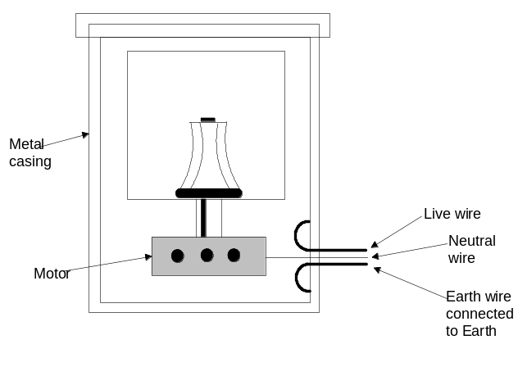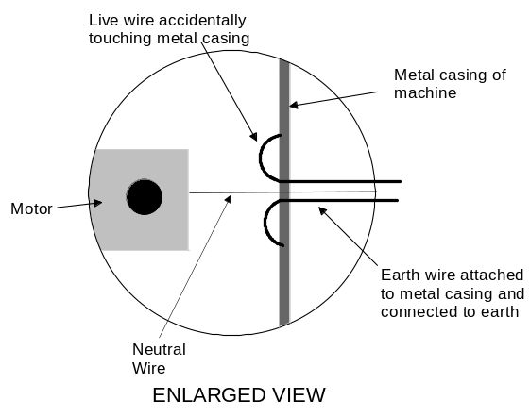
Two students are asked to predict what will happen when a person touches the ‘live’ casing.

One student says that nothing serious will happen to the person.

The other student says the person will receive a severe electric shock.

Who is right and why?
(2 marks)

b) Modern hand-held appliances, such as hair dryers and power tools, use double insulation as a method of safe-guarding users from electrocution. Explain, with the aid of a diagram the principle of double insulation and how a typical design differs from the washing machine in part a) above. (3 marks)

(See next page for part c)

c) Any type of electrical appliance can have exposed live wires or parts if it is badly damaged or cords are frayed (worn out). Explain how an RCD (residual current device) installed in the household electrical network can protect users of faulty equipment. (2 marks)

END OF SECTION A
Section B: Problem Solving

Marks allotted: 100 marks out of a total of 200 (50%)

This section contains 8 questions.

Answer the questions in the spaces provided.

Question 1 (15 marks)
According to the manual for a microwave oven it is 85% efficient in transferring electrical energy into heat energy for cooking food. The oven is rated at 800 W on its highest setting and is plugged into the 240 V mains outlet. To test how accurate this statement is, the following experiment was conducted by students in a school laboratory.
A 0.3 kg glass vessel containing 750 mL of water at 20ºC was placed in the oven and the highest setting selected. The oven was switched on and a timer started at that instant. The timer was stopped the instant the water started to boil. The glass container was 10 ºC hotter than the water when the water boiled. The time taken for the water to boil was
6 minutes 50 seconds minutes.
(specific heat capacity of glass = 840 J K⁻¹ kg⁻¹)

- Calculate the quantity of heat absorbed by the glass vessel and the water. (5 marks)

- Calculate the quantity of energy used by the microwave oven. (3 marks)

c) Calculate the efficiency of the microwave oven. (5 marks)

d) Is the claim that the microwave oven is 85% efficient correct? Explain your answer. (2 marks)

Question 2 (12 Marks)

In a laboratory exercise students set out to verify the specific heat capacity of a liquid they were not familiar with. They measured 0.50 kg of the liquid accurately into a beaker and placed the beaker on a calibrated hotplate. The hot plate was set to transfer a constant quantity of heat to the liquid. The students collected data as the experiment progressed and recorded the results. A table of their results is below.

Quantity of heat (J) | Temp (ºC)
0 | 25
5890 | 30
11 800 | 35
17 600 | 40
23 500 | 45
30 400 | 50
35 300 | 55
41 200 | 60
47 000 | 65
53 000 | 70
58 900 | 75

a) On the grid below, graph the results of the experiment. (5 marks)


- Use the graph and the data provided to calculate the specific heat capacity of the unknown liquid. (5 marks)

- The students were told that the liquid was either:

Ethanol (c = 2.44 x 10³ J K⁻¹ kg⁻¹)
Methanol (c = 2.14 x 10³ J K⁻¹ kg⁻¹)
Polyethylene (c = 2.93 x 10³ J K⁻¹ kg⁻¹)
Which liquid do you think the students were trying to verify? (2 marks)

Question 3 (10 marks)
A teacher set up an experiment to demonstrate a scientific concept about heat. In a strictly controlled demonstration she placed cotton wool around the bulbs of two thermometers. The cotton wool on one thermometer was saturated with distilled water and the cotton wool on the second thermometer saturated with methylated spirit. The two thermometers were then clamped in retort stands and left for a length of time. After the elapsed time the temperatures of the thermometers were both observed to be lower than at the start of the experiment. There was also a 5.0 ºC difference between the two thermometer readings.
- List four (4) variables that the teacher would have controlled in the experiment. (4 marks)

- Explain why the temperature readings of both thermometers were lower than at the start of
the experiment. (3 marks)

- Explain why there was a difference of 5.0 ºC between the two readings. (2 marks)

- Suggest what scientific concept about heat the teacher may have been trying to demonstrate. (1 mark)

Question 4 (15 marks)
Below is a diagram of an electrical circuit set up by a teacher to test student’s understanding of voltage, current and resistance? The circuit consists of resistors connected to a battery with a stated emf of 120 V.

B
15 Ω
10 Ω
4 Ω
30 Ω
18 Ω
9 Ω
emf 120 V
A
D
C

a) Calculate the effective total resistance of the circuit. (3 marks)

b) Determine the current in the circuit at point A (2 marks)

c) Calculate the voltage drop across the 4.0 ohm resistor. (2 marks)

d) If the current is measured at point B, will the value of the current be? (1 mark)
- 2/3 of that measured at A
- The same as measured at A
- 1.5 of that measured at A
- ¼ of that measured at A?
Place your answer (A, B, C or D) in the box opposite

e) Explain why you chose your answer to (d) above. (2 marks)

f) Calculate the quantity of charge that flows through the circuit in 2.0 minutes. (2 marks)

g) The battery can supply 1.50 MJ of energy. For how long could this battery operate if it
constantly supplies this quantity of energy? (3 marks)

Question 5 (10 marks)
As a laboratory exercise students were set the task of determining the latent heat of vaporisation of water. They were provided with all the necessary equipment and preceded to perform the experiment. They followed the steps listed below.

1 A styrofoam cup was weighed. Its mass was 3.00 g
2 A quantity of distilled water was placed in the cup.
3 The cup plus water was reweighed and the new mass was 208 g.
4 The temperature of the water was then taken and recorded as 21.0 ºC
5 A quantity of distilled water was then placed in a conical flask, which had a glass delivery tube, fitted to it.
6 The conical flask was heated on a hot plate to boil the water and produce steam.
7 The steam was passed through the delivery tube and bubbled into the styrofoam cup containing the distilled water.
8 The temperature of the water in the styrofoam cup was monitored as the steam was bubbled into it.
9 When the temperature reached 80.0 ºC the delivery tube was quickly removed and the styrofoam cup and water was weighed. The mass of the cup and its contents was 230 g.

- Using the data collected by the students, calculate the value of the specific latent heat of water. (4 marks)

- The accepted value for the specific latent heat of water is 2.26 x 10⁶ J kg⁻¹. Calculate the
percentage error in this experiment. (2 marks)

- Given the method performed and the equipment used do you think this is an acceptable result?
Explain your answer. (2 marks)

- The students used a 40 cm long delivery tube between the conical flask and the styrofoam cup. Explain why the relatively long tube could affect the accuracy of the experiment. (2 marks)

Question 6 (15 marks)
Below is a circuit diagram containing meters that will measure potential differences and current at certain positions in the circuit.
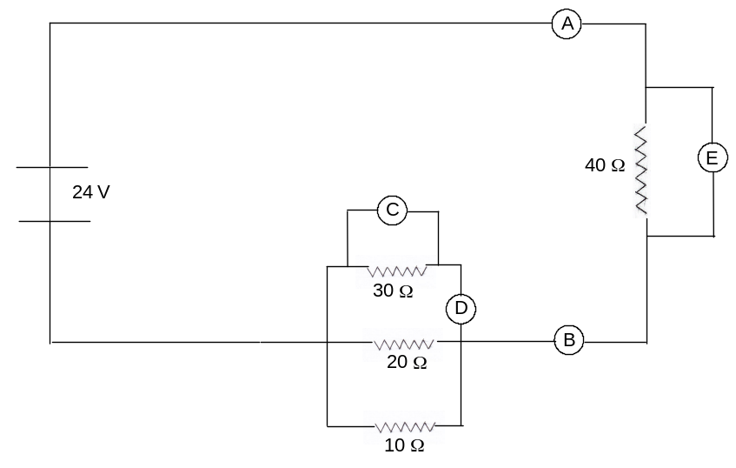

- Which meter(s) A, B, C, D or E is measuring the total current in the circuit? (2 marks)

- Which meter(s) A, B, C, D or E is measuring the potential drop across the 30 Ω resistor? (2 marks)

- Which meter A, B, C, D or E is measuring the current in the 40 Ω resistor? (2 marks)

- What is the reading on meter D? (value and units) (3 marks)

- What is the reading on meter E? (value and units) (2 marks)

- Does size of the current depend upon where it is measured in a series circuit?
Explain your answer. (2 marks)

- What is the relationship between the current in individual resistors in parallel, and the total
current entering and leaving the group of resistors in parallel? (2 marks)

Question 7 (8 marks)
Below is a heating graph for an unknown substance. The graph is the result of collecting data
when 10.0 g of the solid substance is heated until it has vaporised. Examine the graph and
answer the following questions.

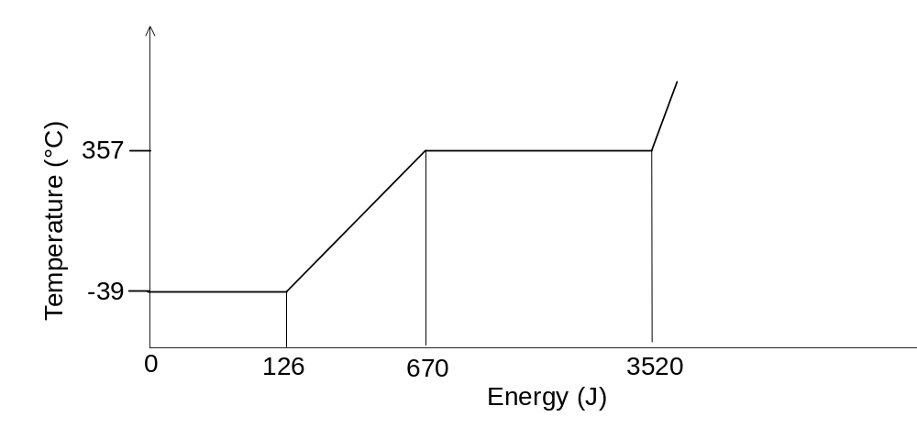
- Explain why the temperature remains constant during the first part of the graph. (1 mark)

- What is the melting point of the substance? (1 mark)

- What is the boiling point of the substance? (1 mark)

- What is the specific latent heat of fusion of the substance? (2marks)

- What is the specific latent heat of vaporisation of the substance? (2 marks)

- Is the unknown substance water? Explain your answer. (1 mark)

Question 8 (15 marks)
a) When a plastic rod is rubbed with a cloth it can become negatively charged. Explain,
using electrostatic principles how the plastic rod becomes charged. (2 marks)

b) When charged small pieces of paper can be attracted to the rod. Explain in terms of
electrostatics how this occurs. (2 marks)

c) After a short time the paper is observed to fall from the rod. Explain why this happens. (2 marks)

d) Explain why it is impossible to charge a copper rod by rubbing it with a similar cloth. (2 marks)

e) Below is a diagram of two charged plates. A proton is at rest on the positive plate. On the
diagram draw arrows to show the position and direction of the electric field associated
with the plates. (2 marks)

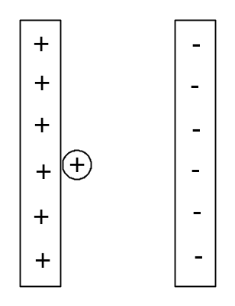

f) If the potential difference between the plates is 12.0 V, calculate the maximum speed that the
proton will reach in this potential difference. (5 marks)

END OF SECTION B

Section C: Comprehension and Interpretation

Marks allotted: 20 marks out of 200
Question 1 (7 marks)
Powder-coating transforms a wide range of metal objects.
These include white goods, metal chairs and tables, car
parts, steel pergola frames and so on. Although the ideal
finish is smooth and shiny, it is always a problem to
prevent the powder forming unsightly ‘blobs’ on the
coating. Electrostatics provides an answer. How does it
work? An electrostatic powder spray system is a highly
efficient technology for applying powder. The process
involves forcing powder through a spray gun barrel
where it rubs against the internal surface. This rubbing
causes powder particles to pick up additional electrons
and become negatively-charged.

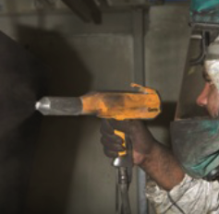
The object to be coated is grounded.
The charge difference between powder and object attracts powder to the object giving it a more even coat as well as increasing the percentage of powder that sticks to the object. It also means that powder covers hard-to-reach areas.

Powder particles that pass the object can be attracted to, and deposited on the back of the object. This phenomenon is known as ‘wrap’. As the coating is deposited on the object being treated, the charge dissipates through the ground and returns to the power source, completing the circuit.

Finally, to properly attach the powder, the object is baked.

Due to the typical transfer efficiency of the system, it is possible to achieve nearly 100% use of the coating with some systems through recycling of powder overspray. As electrostatic powder spray systems operate at high voltages (from 30 to 150 kV) safety of operators is a high priority. For instance, all items, including the operator, must be grounded.
Ungrounded items should be removed. Operators should never wear rubber or cork-soled shoes.

Questions
1 What is meant by the term ‘grounded’? (1 mark)

2 Why does the item being powder-coated need to be grounded? (2 marks)

3 Would it matter if some of the powder particles being sprayed were positively-charged and
some were negatively-charged? Explain your answer. (2 marks)

4 Why isn’t electrostatic powder-coating used when spraying items made of plastic?
(1 mark)

5 The passage mentions metal furniture and steel pergola frames as examples where electrostatic powder-coating is particularly effective. Why are these two items regarded as being suitable to be powder-coated? (1 mark)

Question 2 (13 marks)
A town council in the northern suburbs of Perth is proposing to use geothermal energy to heat its community swimming pool. The aim is the sink a bore to a depth of 800 m to tap into the Perth Basin aquifer. At this depth water at a temperature of 43.0 ºC can be accessed. The water will be pumped to the surface, circulated through a heat exchanger, and returned to the aquifer without mixing with pool water. The heat exchanger is expected to be 90% efficient in transferring energy from the geothermal water to the pool water.

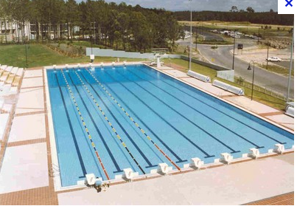

It is estimated that the temperature of the geothermal water will be 2.0 ºC cooler by the time it reaches the heat exchanger.
It is proposed that the temperature of the pool be kept at 26.0 ºC so it will be comfortable for swimmers to use the pool all year round. Heat losses from the pool will occur so the circulation of warm water will need to be ongoing to compensate. In Perth most energy is lost from swimming pools during the month of October. An Olympic size swimming pool loses an average
of 915.0 kJ s⁻¹ during this peak-loss time.

Questions
1 At what rate does energy need to be provided to the pool to maintain a temperature of
26.0 ºC? (1 mark)

2 At what rate does geothermal water need to be pumped into the heat exchanger so the
temperature of the pool is maintained? (6 marks)

3 The main loss of energy from the pool is due to vaporisation of the surface water.
Explain how this contributes to heat loss. (2 marks)

4 Would the geothermal water need to be pumped at a constant rate in a 24 hour period to
maintain the temperature of the pool at 26.0 ºC? Explain your answer. (2 marks)

5 Apart from heat loss due to vaporisation, how else would energy be lost from the pool? (2 marks)

END OF EXAM

